Polaris: Data Analytics

Assignment 1

Student Name: Tse Kit Yee

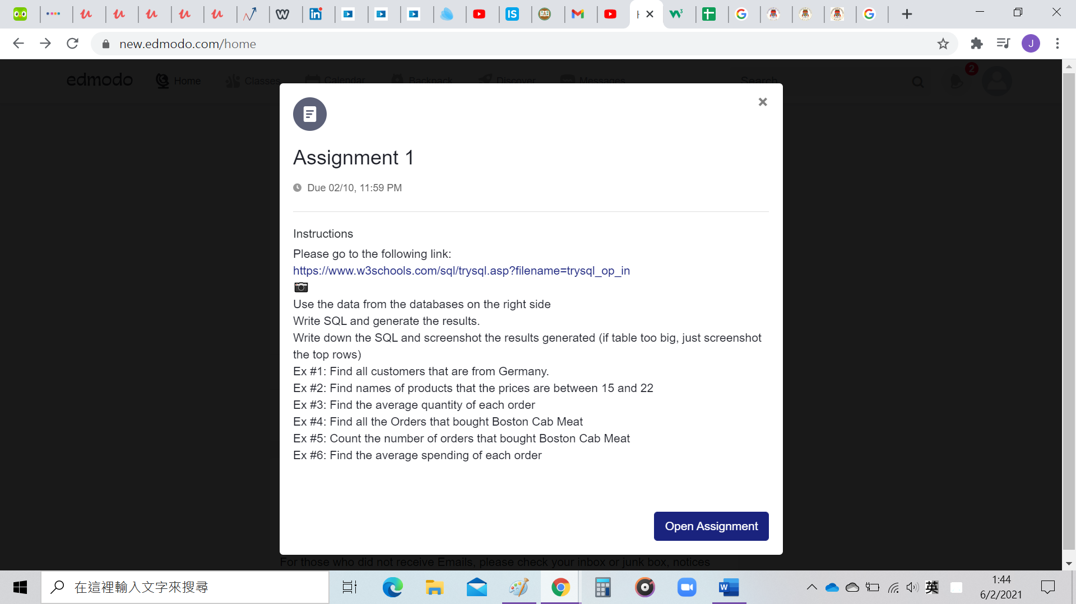

ANS:

Ex #1: Find all customers that are from Germany.

SQL: SELECT CustomerName, Country FROM [Customers] where Country='Germany'

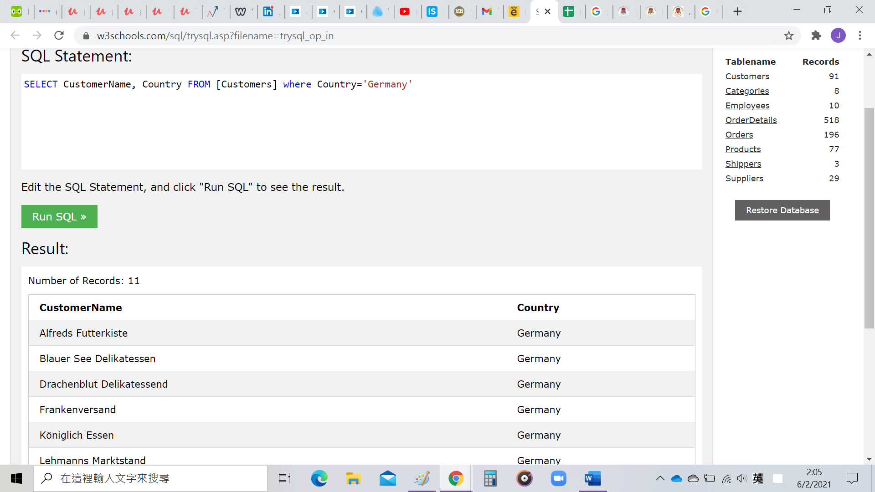

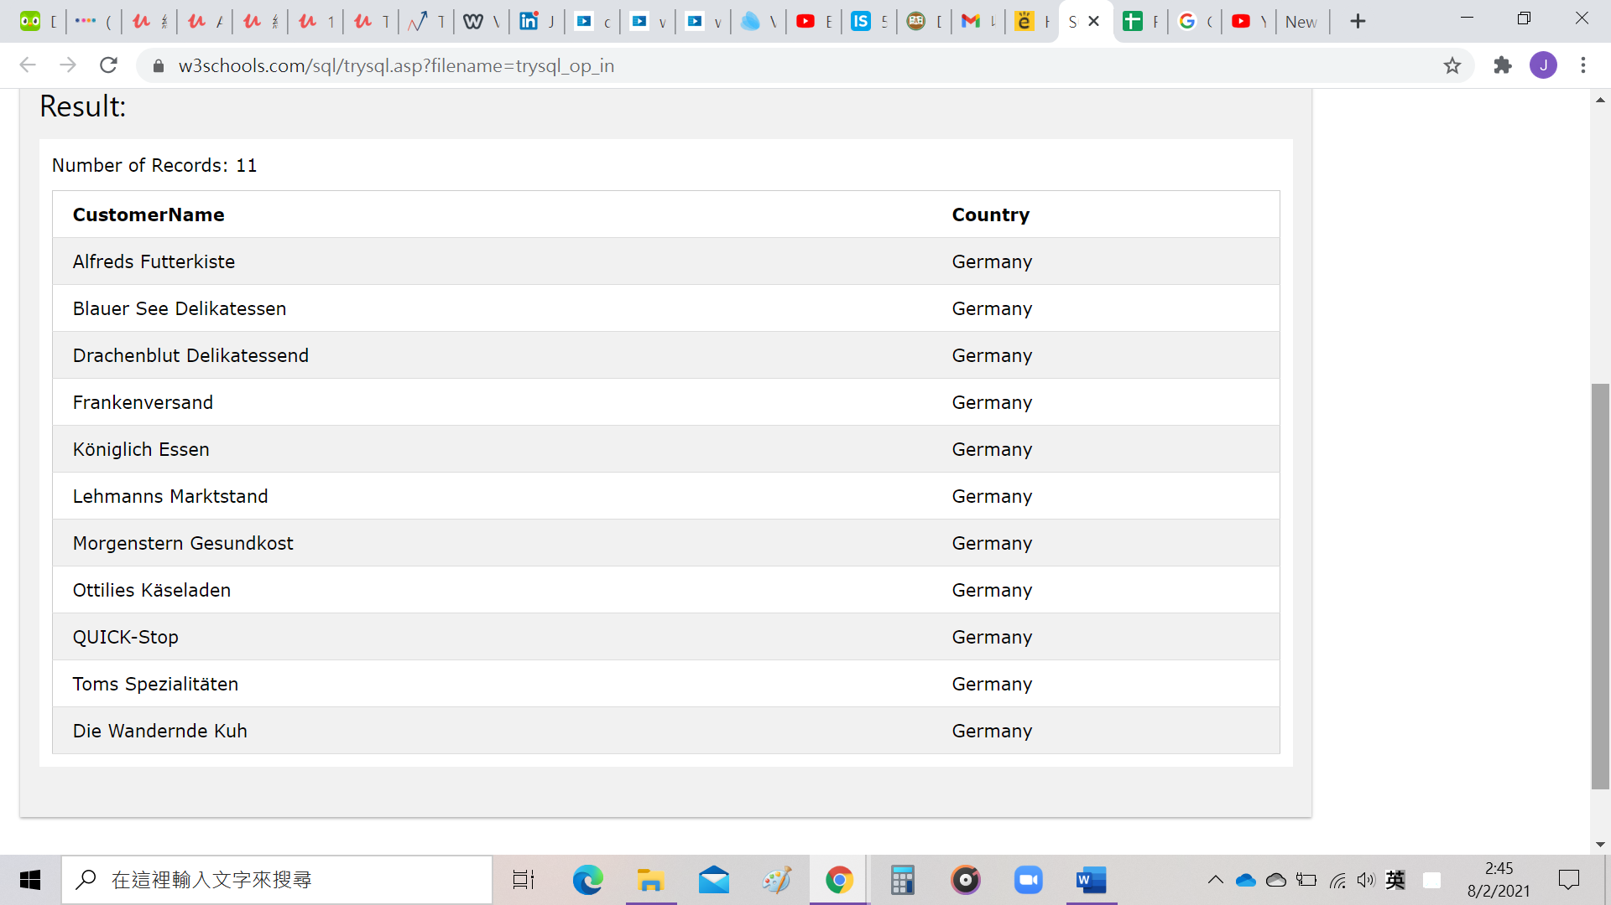

Ex #2: Find names of products that the prices are between 15 and 22

SQL: SELECT ProductName, Price FROM [Products] where Price>=15 and Price<=22

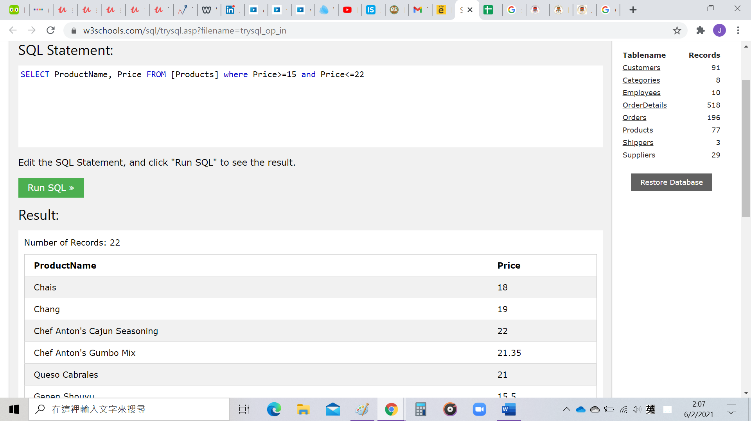

Ex #3: Find the average quantity of each order

SQL: SELECT OrderID, Avg(Quantity) as Mean_Quantity FROM [OrderDetails] group by OrderID

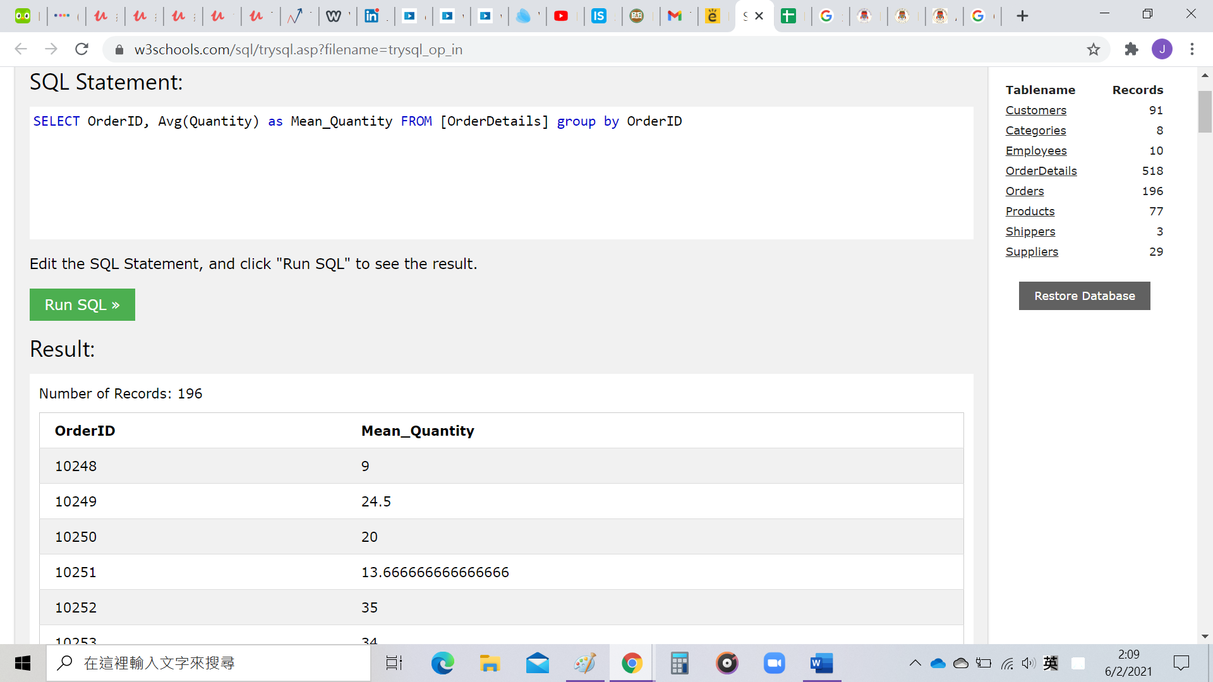

Ex #4: Find all the Orders that bought Boston Crab Meat

SQL:

SELECT OrderID, ProductName FROM OrderDetails, Products

where OrderDetails.ProductID = Products.ProductID and ProductName='Boston Crab Meat'

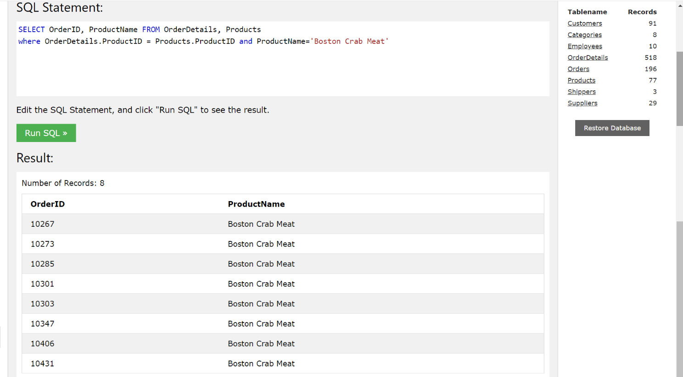

Ex #5: Count the number of orders that bought Boston Cab Meat

SQL:

SELECT OrderID, ProductName, Sum(Quantity) as total_num_orders FROM OrderDetails, Products

where OrderDetails.ProductID = Products.ProductID and ProductName='Boston Crab Meat'

group by OrderID

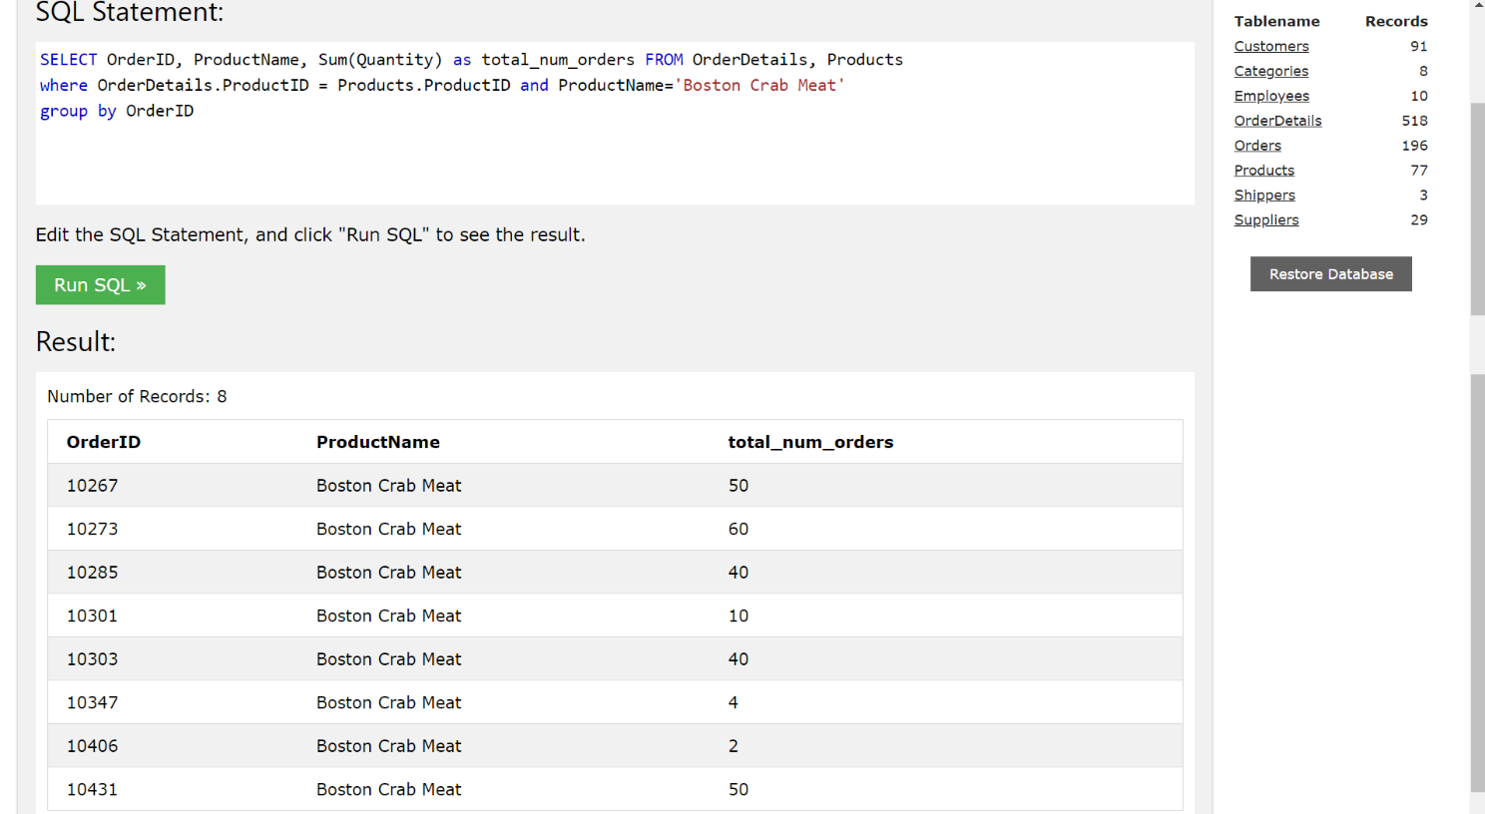

Ex #6: Find the average spending of each order

SQL:

SELECT OrderID, ProductName, Avg(Price) as mean_price FROM OrderDetails, Products

where OrderDetails.ProductID = Products.ProductID

group by OrderID

